ISTE-TN&P Section Lifetime Achievement Awardees 2017 – For Recognizing Outstanding Professional Service

S.No | Name/Qualification | Experience | Division | Contact Address | Photo
1 | Dr. E.Ramasamy  DOB: 24.04.1948  AGE: 69 Years | Principal at Salem (1994-1996)  Principal at Alagappa Chettiyar College of Engineering & Technology, Karaikudi (1996-1998)  Additional Director of Technical Education, Polytechnics (1998-2005) | Metallurgical Engineering | 70/71, Second Main Street,  Renga Nagar,  Trichy- 620021  Cell: 8526024516 | 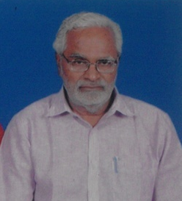
2 | Dr. S.Gopalakrishnan  B.Pharm, M.Sc. (Pharmacy), Ph.D.  DOB: 23-3-1942  Age:76 Years | Former Professor of Pharmaceutics, Madras Medical College, Chennai  Former Professor of Sri Ramakrishna Institute of Para - Medical Sciences | Pharmacy | 21, Anna Salai  Rasipuram - 637408  98430 25487  sgka@rediffmail.com | 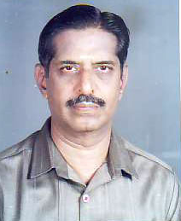
3 | Dr. K.Nallathambi  DOB:10.01.1942  Age: 75 years | Retired principal  Government Engineering College, Salem  Former Director,  KSR Engineering College  Tiruchengode | EEE | Vivek Illam  Verma Garden  Yercaud Main road  Chinna Kollapatti  Salem-636008  9994586487 | 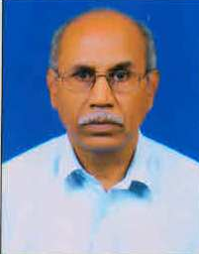
4 | Dr. S.J. Jeyapaulan  DOB: 15-04-1944  Age: 73 years | Former Principal  CSI College of Engineering  Ketti, Nilgiris | EEE | 1/80, Velammal Colony  NGGO colony  Coimbatore-641022 | 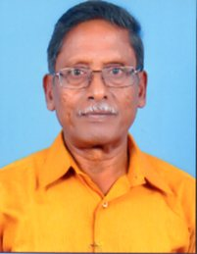
5 | Dr. M.Y. Sanavullah  DOB: 15.10.1942  Age: 68 Years | Former Principal  V.M.K.V. Engg College  Salem  Former Dean / EEE,  K.S.R. College of Technology  Tiruchengode | ECE | 1/11 Sriram Nagar,  Salem 636 006 | 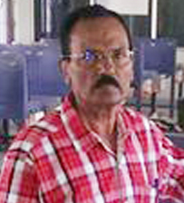
6 | Dr. R. Manavalan  DOB: 15-10-1951  Age: 67 Years | Research Director ,  Professor &HOD,  Dept of Pharmaceutics, RVS College of Pharmaceutical Sciences, Sulur,  Coimbatore - 641 402. | Pharmacy | Manamathi Illam,  4, Srinivasa Garden,  C.Kothangudi,  Chidambaram  Tamil Nadu, India  Mobile: 9443348426  manamathi_07@yahoo.co.in manavalan@rvsgroup.com | 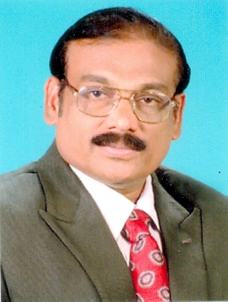
7 | Dr. V.Prithviraj  DOB: 06-01-1951  Age: 66 Years | Adjunct faculty of JSSS&T University  Former, Dean School Engineering at Pondicherry University | ECE | 12, MES Road  Thambaram  Chennai-600059  9443536633  vpraj@gmail.com | 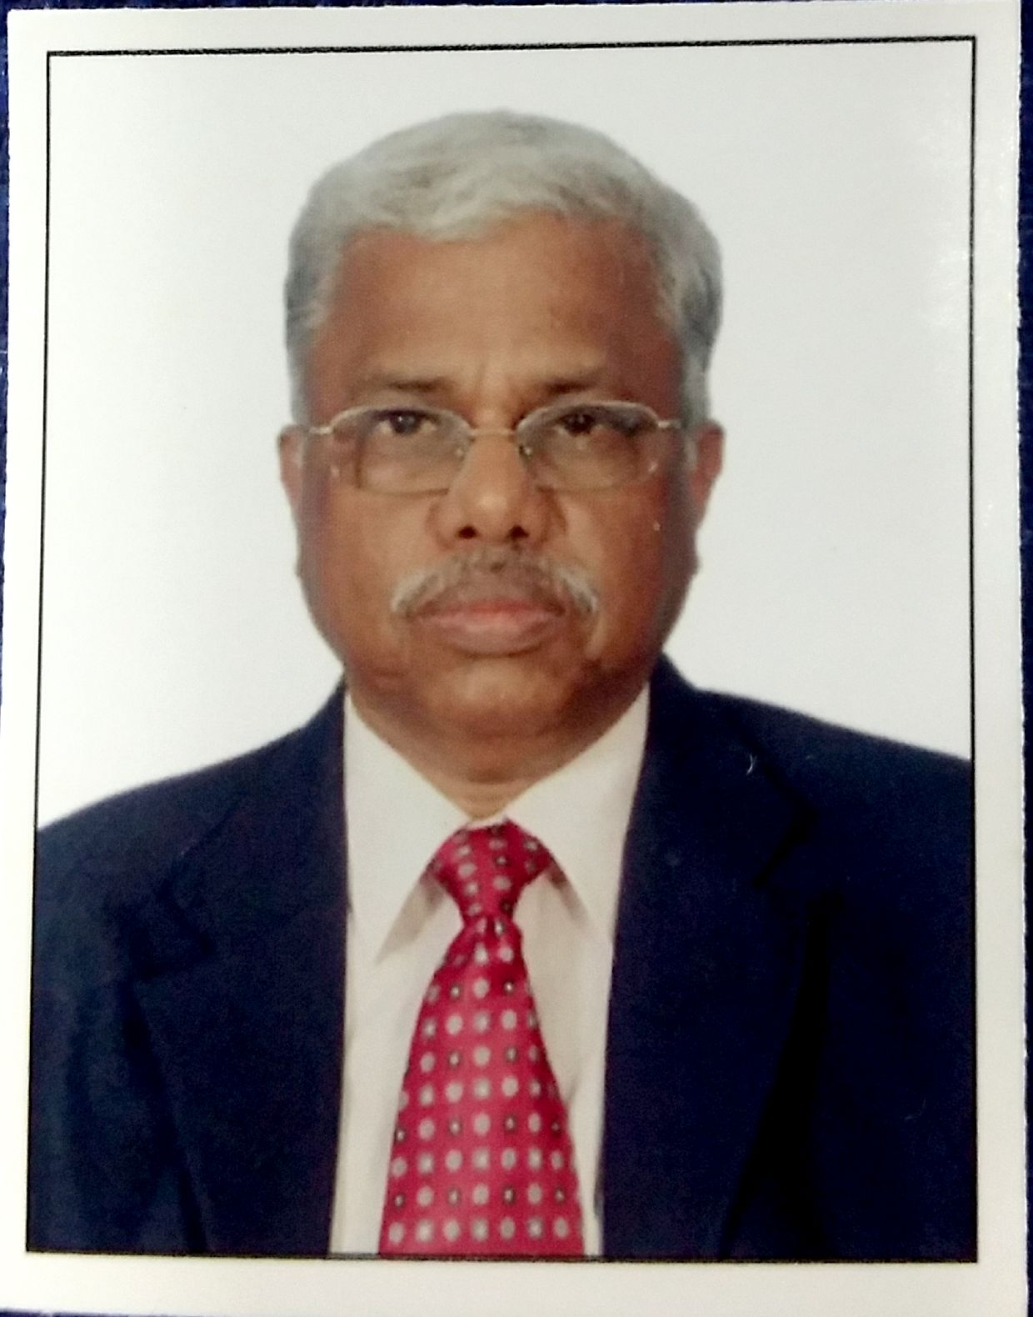
8 | Dr. T. James Wilson  DOB : 20-10-1951  Age: 66 Years | Former Professor & Head  PSN College of Engg. & Tech  Palayankottai  Chairman,  Marthandam College of Engg. & Tech, Veeyannoor Post,  Kanyakumari - 629 177 | Marine Engineering | Sigma, Chankai, Kanjiracode, Kanyakumari Dist  9443370072  dr.jameswilson2012@gmail.com | 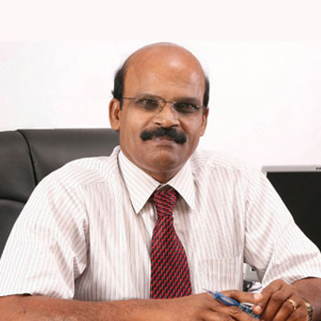
9 | Dr. R. Joseph Xavier  27.07.1951  Age: 66 Years | Former Principal  VLB College of Engineering,  &  Ramakrishna Institute of Technology, Coimbatore | EEE | 7/112A, Pudunagaram, E.B.Colony  Kuniamuthur (P.O). Coimbatore – 641008.  9842618005  94899 15599. prof.rjx@gmail.com
10 | Dr. R. Sundararajan  DOB:26-06-1953  Age: 64 Years | Registrar  Karpagam University  Coimbatore  Retd.  Principal, GCT Coimbatore  UGC | Civil Engineering | 94431 16013  e mail: register@kahedu.edu.in | 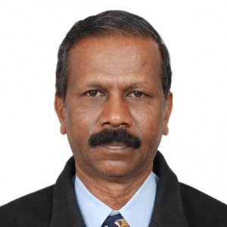
11 | Dr. R.Chandrasekhar  DOB: 30-05-1954  Age: 63 Years | Professor- Healthcare Trainer-Consultant  Dean-Kalasalingam School of Business, Kalasalingam University Krishnankoil, Tamilnadu | MBA | 36, CS Nagar, Extension,  II Cross Road  Vadavalli  Coimbatore – 641 041  deanmgt@klu.ac.in, chandramenon@ymail.com swiftmba@gmail.com  944 222 6036  96 113 11136. | 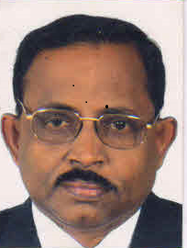
12 | Dr. S.Salivahanan  DOB: 03.10.1954  Age: 63 Years | Principal  SSN College of Engineering  Rajiv Gandhi Salai (OMR)  Kalavakkam - 603110 | ECE | salivahanans@ssn.edu.in  Mobile: 09444189433 | 