ISTE-TN Section Lifetime Achievement Awardees 2018 – For Recognizing Outstanding Academic Service

S.No | Name/Qualification | Experience | Division | Contact Address | Photo
1 | Dr. A. NATARAJAN  DOB: 01.06.1942  Age: 77 years | 2001-2012(11 years)  SONA College of Technology, Salem.  T.N.E.B as AE in the year 1964  Recipient of Gold medal of TNEB | Thermal Power generation, | 3/179,  MGR Nagar,  Mamangam,  Salem-636302  98427 23472  natarajan42@yahoo.com | 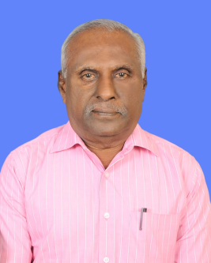
2 | Dr.A.KANDASAMY  DOB: 3 -3- 1944  Age:75 years | Dean, Industrial Research and Development  PSG College of Technology, Peelamedu Coimbatore-641 004 | EEE | 166/64, Nanda Nagar  Singanallur, Coimbatore  Tamil Nadu. PIN-641 005, INDIA | 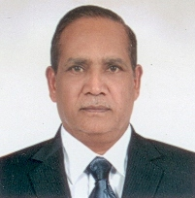
3 | Dr, M,MANICKAM  DOB: 30.11.1947  Age: 71 years | Professor and Head. Department of Commerce  Bharathiar University  Coimbatore-641046 | Management | Vadavalli  Coimbatore  Cell:9894212151 | 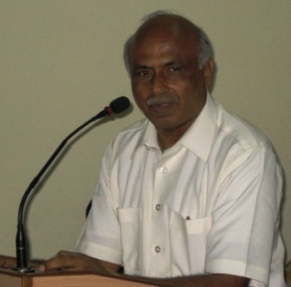
4 | Dr. R. JOSEPH XAVIER  DOB:27.07.1951  Age: 67 Years 9 Months | Former Principal  VLB College of Engineering,  & Sri Ramakrishna Institute of Technology, Coimbatore | EEE  LM12070 | 7/112A, Pudunagaram, E.B.Colony  Kuniamuthur (P.O). Coimbatore – 641008.  9842618005, 94899 15599. prof.rjx@gmail.com
5 | Dr. K.SANKARA NARAYANAN  DOB: 15-6-1952  Age: 66 years | Professor and Dean  PA College of Engineering and Technology, Coimbatore  38 Years 11 Months | ECE | R. Block No. 81/D  Kovaipudur  Coimbatore - 641042  9443126363 | 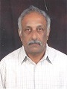
6 | Dr. N. KUPPUSWAMY  DOB: 05.10.1952  Age: 66 years | Dean,  KalaignarKarunanidhi Institute of Technology  Coimbatore | Mech. Engg. | A 3 Sai Brindhavan  Vijayashree Gardens  EllaiThottam Road Extn. Peelamedu (Po),  Coimbatore – 641004  94433 77203  kuppuswamynks@gmail.com | 
7 | Dr. V.K.SHUNMUGHANAATHAN  DOB: 14.04.1953  Age: 66 years | Director – Administration,  Excel group Institutions,  Komarapalayam -637303 | Mechanical Engineering | 9842742890,  profvksnathan@yahoo.com | 
8 | Dr. A.SABANAYAGAM  DOB: 07-03-1954  Age: 65 years | Principal in Karpagam Institute of Technology, Coimbatore | ECE | 17, Varma City,  MannarpalayamPrivuRoad,  Allikuttai(P.O),  Salem-636017  Cell: 9344132508  E-mail Id: sab19542008@gmail.com | 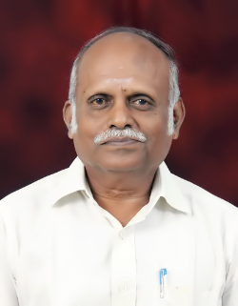
9 | Dr. R.R. ELANGOVAN  DOB: 23-04-1954  AGE: 65 years | HOD,  Department Aeronautical Engg,  ACS College of Engineering  Bangalore | Aeronautical Engg | Plot NO L1,  PJP Gardens, Gangai Nagar First Main Street  Velachery,  Chennai- 600042  Tamil Nadu, INDIA  9176602009 | 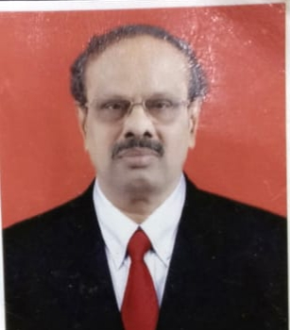
10 | Dr. R.Narayanasamy  DoB: 10-04-1954  Age: 65 years | Professor,  Production Engineering Department,NIT, Tiruchirappalli-620 015 | Metallurgical Engineering | 09443984160  narayan10455@yahoo.co.in | 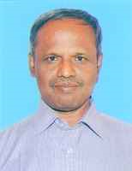
11 | Dr.De Elwin Chandra Monie,  DOB: 06-02-1952  Age: 68 years | Dean – research,  RMK Engineering college,  Chennai.

